**PLC Lab Communications Setup**

**Lab Objectives**

In this lab you will learn the following:

* Opening a new project in the Do-more-Designer
* Establishing a communication link between the PC and the PLC using the USB and Ethernet.

**Lab Duration**

10 – 15 minutes

**Lab Procedure**

The purpose of this lab is to establish an Ethernet link between the PC and PLC in order to run the HMI program. To do this we must first establish a connection between the PC and PLC through the USB.

**Establishing a Link between the PLC and the PC Using USB:**

1. Connect the USB cable to the PC.
2. Open the Do-more Designer program
3. Click on the **USB Icon** and click **Open**. A dialog box will appear.

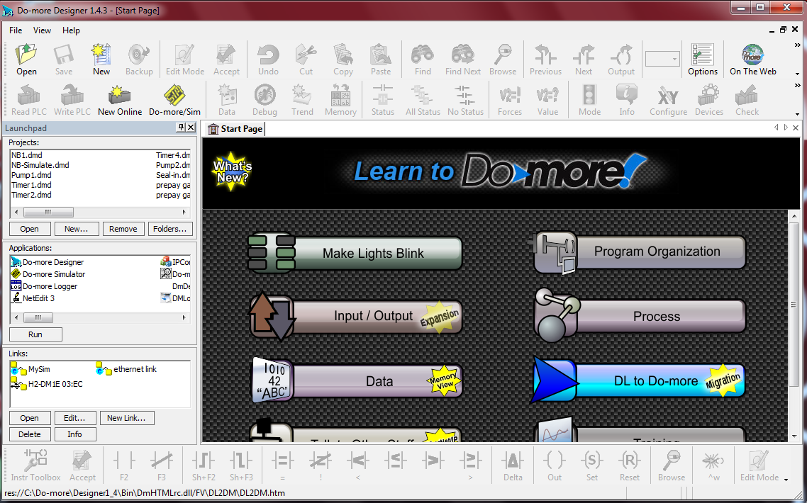

**USB Icon**

1. Click on the **Go Online and View the Disk Project** shown below.

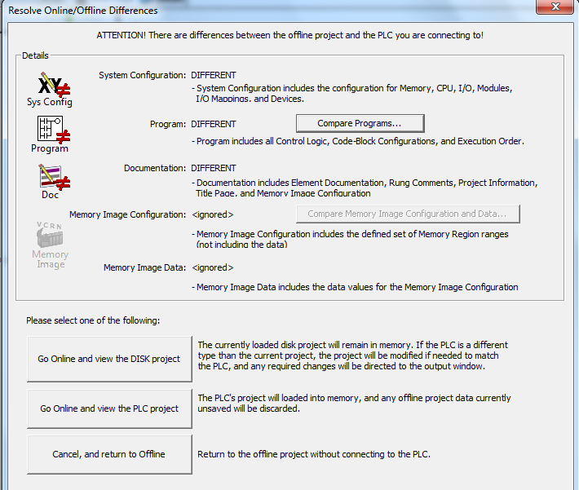

1. Select **Continue Online** when the following window appears.

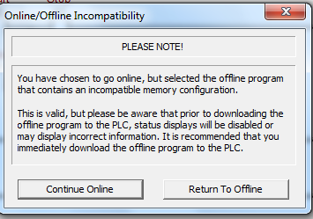

1. Select **Next** when the window below appears.

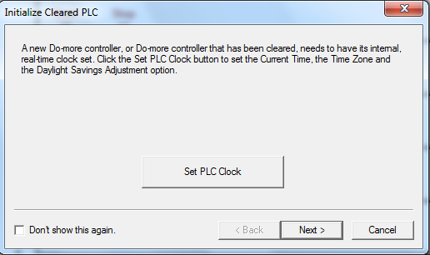

1. Click **Finish** in the window below.

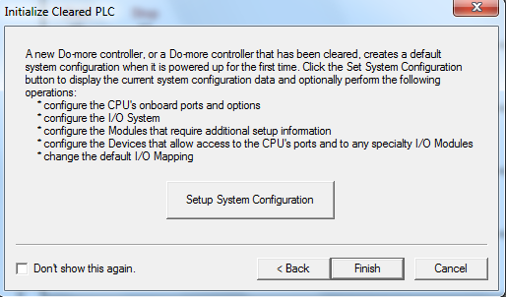

**Establishing an Ethernet Link between the PLC and the PC:**

1. Close the **Launchpad** window shown below. If it is not available, click on the **PLC/System Configuration** from the menu.P

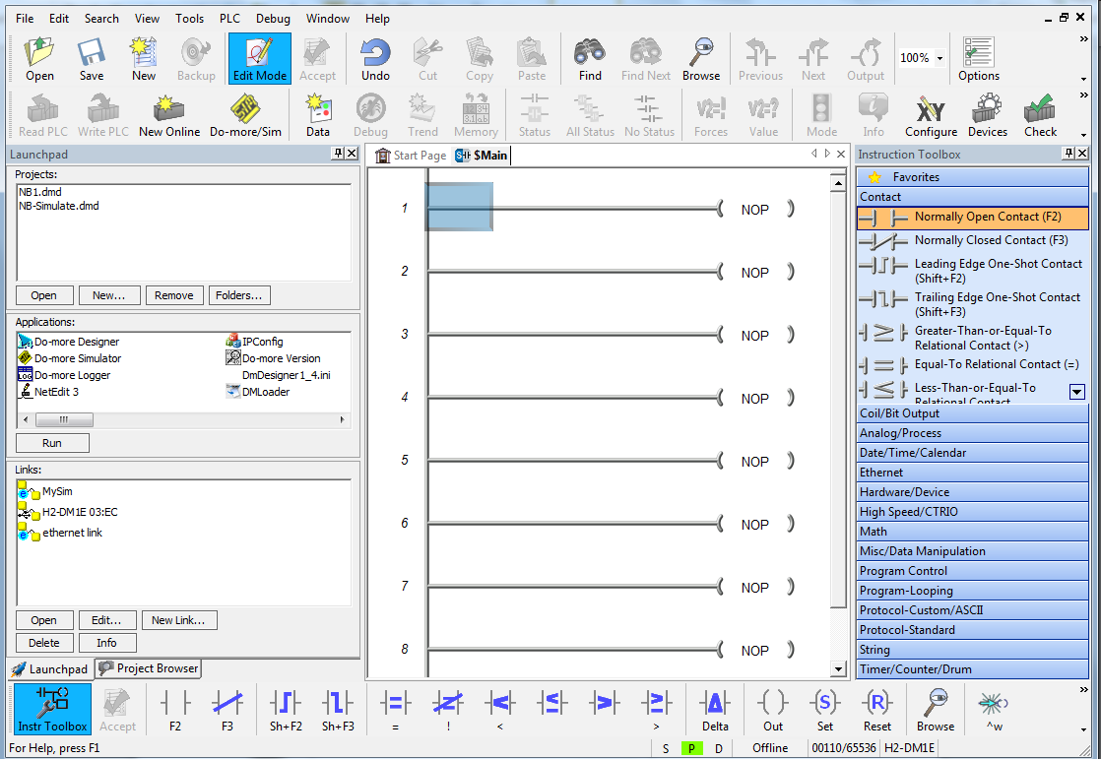

**To Close Launchpad**

1. In the window below, double click on the **System Configuration**.

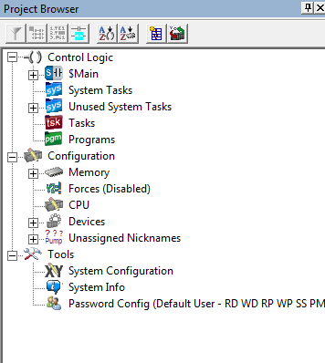

1. When the window below appears, copy the numbers associated with the **IP** address and the **Net Mask**, then click on **Configure**.

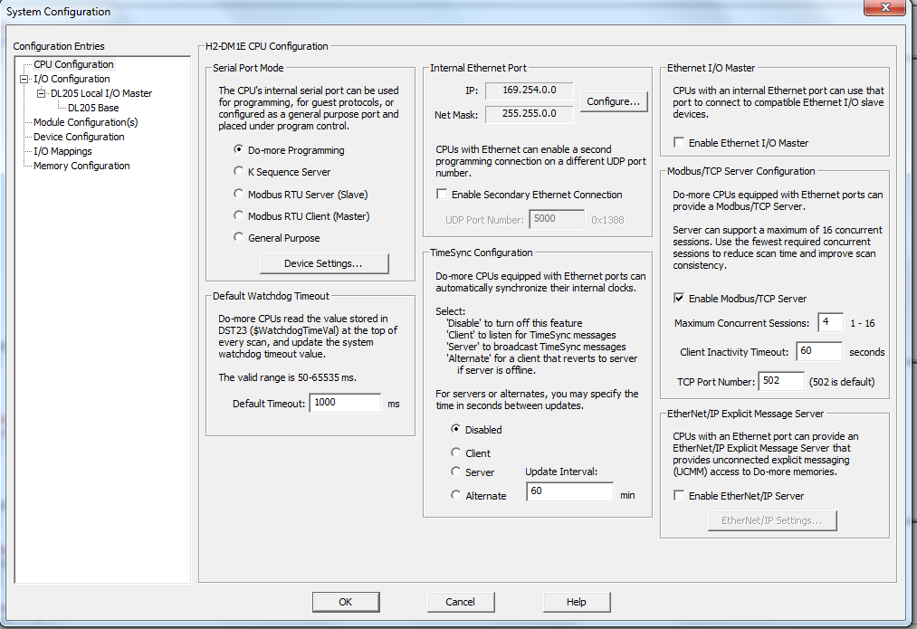

1. Make sure that the numbers that appear in the window below match the ones you wrote otherwise change them accordingly. Then click **OK** on both windows on the screen.

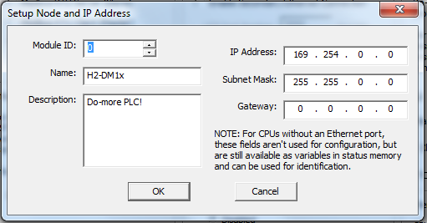

1. Select the **PLC/Disconnect** from the menu, the following window will appear, click **OK**.

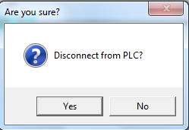

1. Click **PLC/Connect** and in the displayed window and click **Add**.

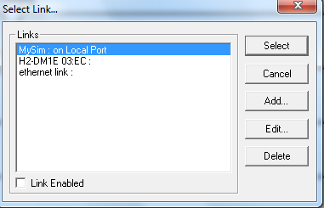

1. Select **Ethernet** in the window below and click **Next**.

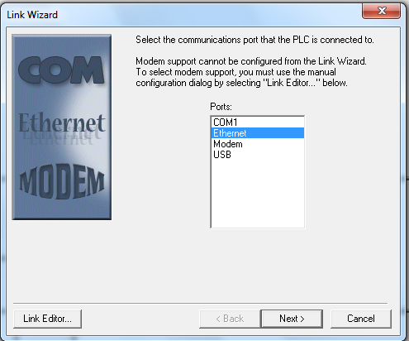

1. In the window below, select **UDP/IP** and click **Next.**

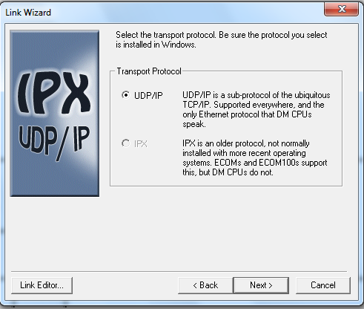

1. Click on the numbers below the **IP address**, they will be automatically copied to the right side of the window below, then click **Next**.

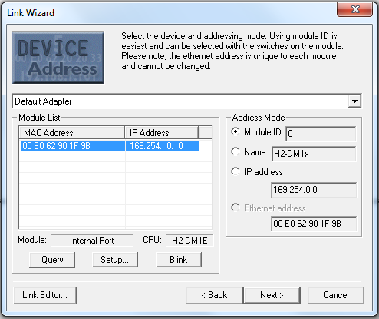

1. In the window below, type any name (e.g Ethernet) in the **Link Name** and click **Finish**.

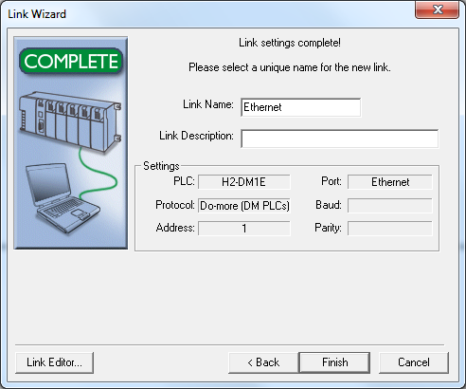

1. In the **Select Link** of the window below, click on the **Ethernet** **Links** if not highlighted and then click **Select**.

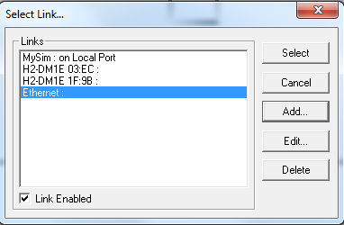

1. Click **Next** in the window below.



1. Click **Finish** in the window below to complete the Ethernet communication between the PC and PLC.

